LAB ASSIGNMENT 12.3

D. VIDHU SREE
2303A52400
BATCH 41

TASK 01: Sorting Student Records for Placement Drive Scenario
PROMPT:
Generate students records of 20members (name, roll number, cgpa) and print them in sorted manner using quick sort and merge sort, also write a function which displays the top 10 students.
Compare the time complexity of both sorting algorithms in large datasets in form of docstrings.
CODE:
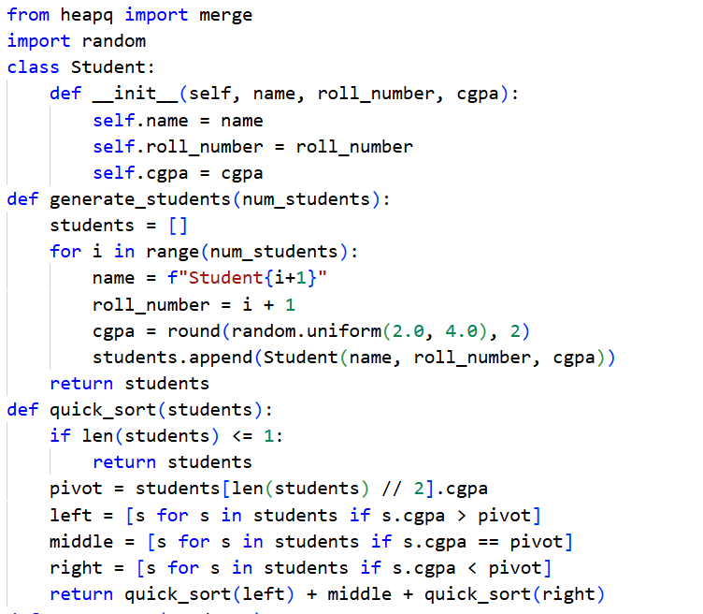
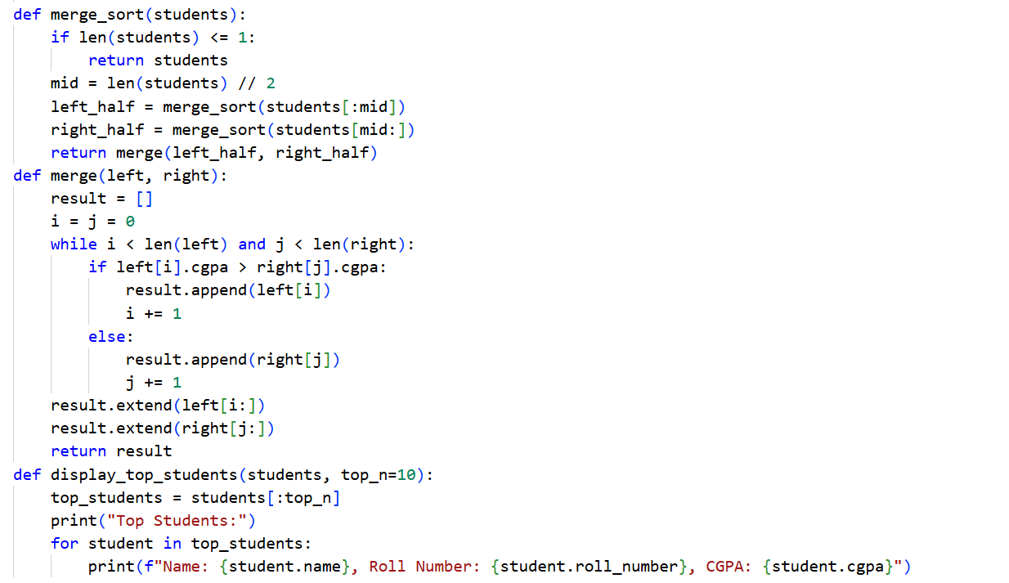
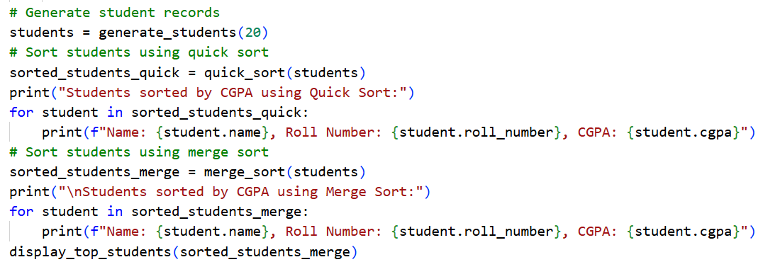
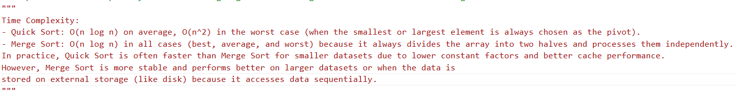

OUTPUT:
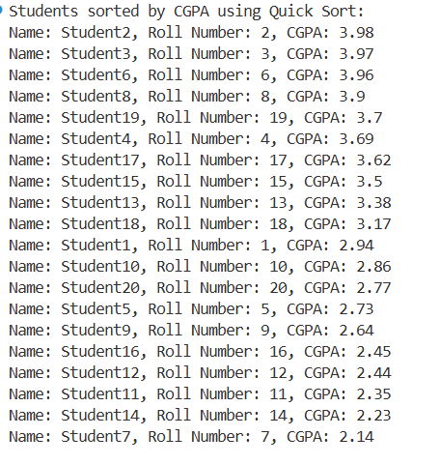
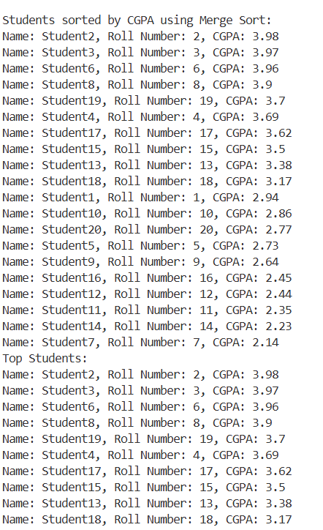
JUSTIFICATION:
In this task, we have sorted the students list with both quick sort and merge sort, even though its both sorting process, way of doing it is different. Time complexity in both quick sort and merge sort is same which is O(n log n) for both best and average cases, whereas in worst case, time complexity in quick sort is O(n^2) meanwhile merge sort is O(n log n), so it is better to use merge sort.

TASK 02: Implementing Bubble Sort with AI Comments
PROMPT:
Implement bubble sort on a unsorted list of 10 random integers and print the sorted list, also provide required comments and also provide time complexity analysis in the end.
CODE:
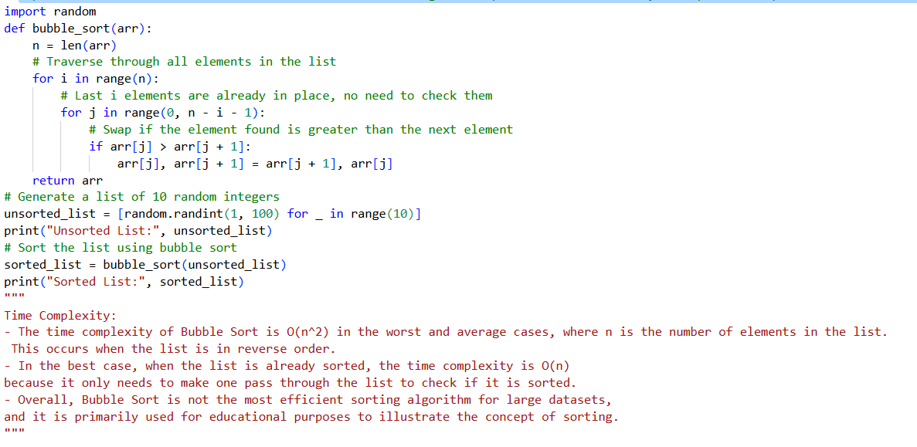
OUTPUT:
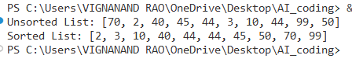
JUSTIFICATION:
In the above task, we have successfully implemented bubble sort technique on an unsorted list of numbers, also provided the required comments which are essential for better understanding of the logic and algorithm. Time complexity of bubble sort in Best case is O(n) whereas in average case and worst case it is O(n^2) which takes more time as it must swap 2 numbers.

TASK 03: Quick Sort and Merge Sort Comparison
PROMPT:
Generate a code for sorting a list using quick sort and merge sort using recursion and print the sorted list, also provide comparison of both the algorithms on random, sorted and reverse sorted lists in form of docstrings.
CODE:
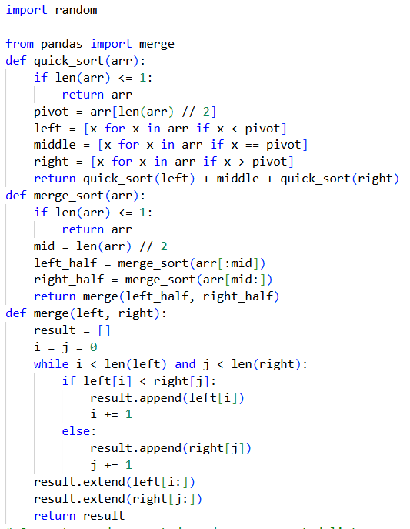
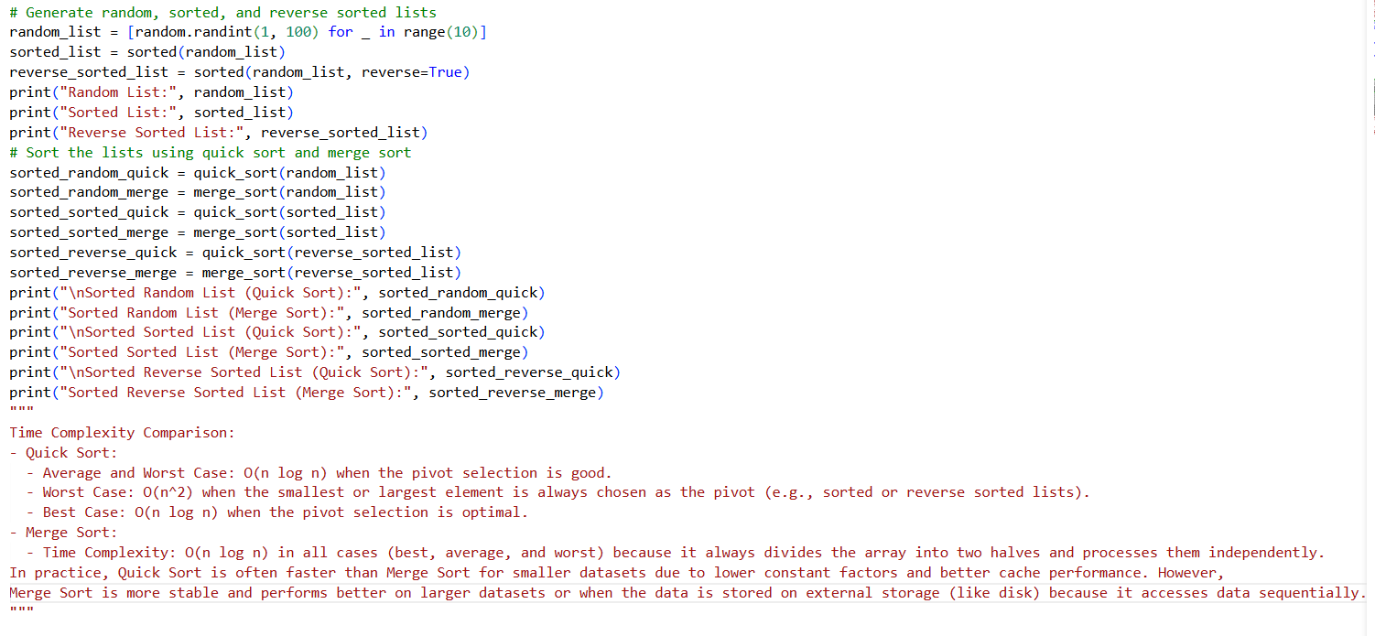
OUTPUT:
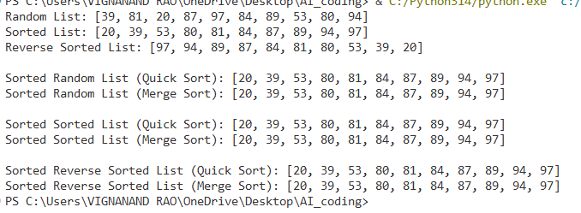
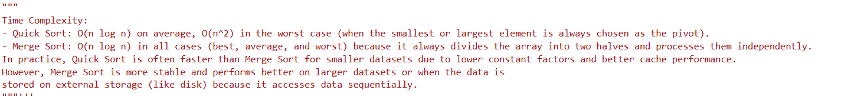
JUSTIFICATION:
In this task, we have implemented both quick sort and merge sort using recursion on all 3 cases, random list which is average case, sorted list which is best case and reverse sorted list which is worst case.
Time complexity of quick sort is O(n log n) in both best case and average case whereas in worst case, it is O(n^2) but for merge sort, time complexity is O(n log n) for all the 3 best, average and worst cases.
TASK 04: (Real-Time Application – Inventory Management System)
PROMPT:
There is a stock list with attributes (product id, name, price, stock quantity), generate a list of 20 items and 2 functions, one for searching the product with productid or name and other for sorting the items by price or quantity for stock analysis. Suggest the best efficient searching and sorting algorithms for this use case, implement them, justify the choice based on dataset size, update frequency and performance requirements, in form of a table mapping (operation -> recommended algorithm -> justification).
CODE:
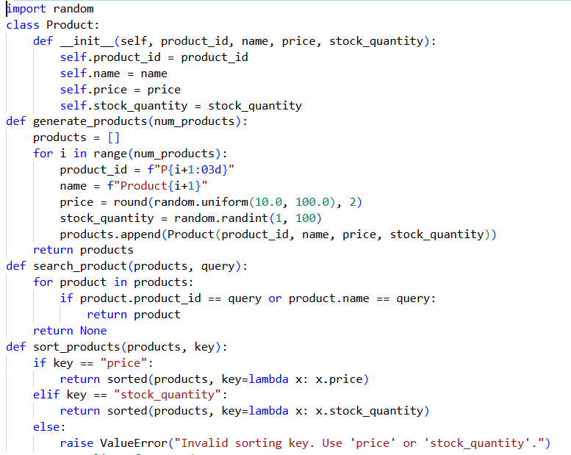
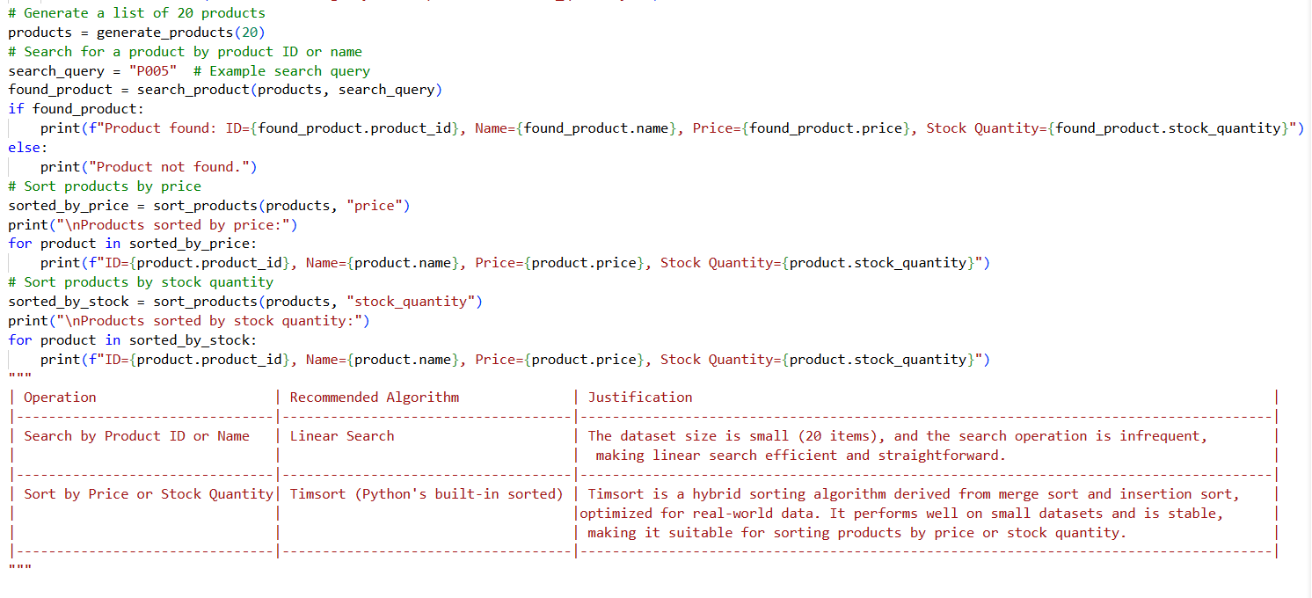
OUTPUT:
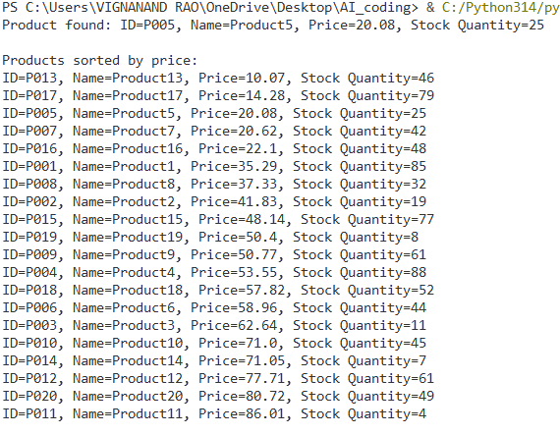
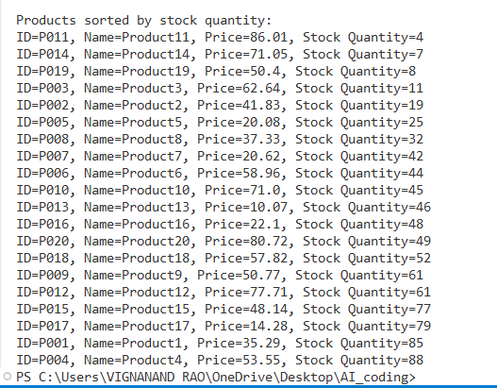
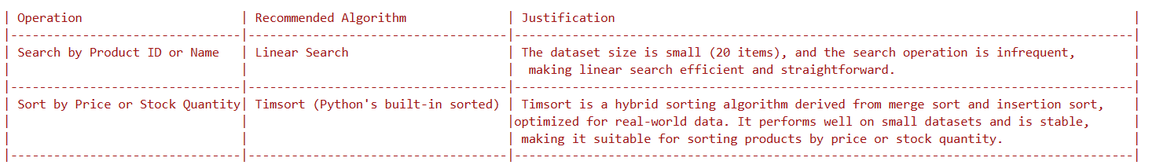
JUSTIFICATION:
In the above task we have using linear search for searching of the required product and we used Timsort(Python’s built-in sorted function) for sorting the items based on product price and also based on product quantity (availability) which is essential for stock analysis. We have implemented both searching and sorting algorithms in the real world scenario.
Timsort is a build-in function of Python which hybrid sorting algorithm derived from merge sort and insertion sort, which is very efficient for real world use cases.

TASK 05: Real-Time Stock Data Sorting & Searching
PROMPT:
generate a code which quickly sort stock price data (Stock symbol, opening price, closing price) by daily gain/loss and search for specific stock symbol efficiently. Implement sorting algorithm to rank stocks by percentage change and implement a search function that retrieves stock data instantly. For sorting use Heap Sort only and for searching use Hash Maps only. Compare the performance with standard library functions (sorted(), dictlookups) and analyze trade-offs in form of docstrings.
CODE:
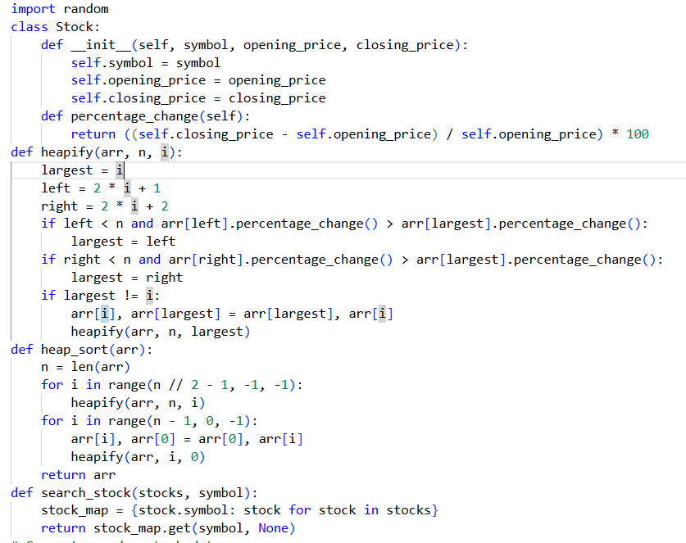
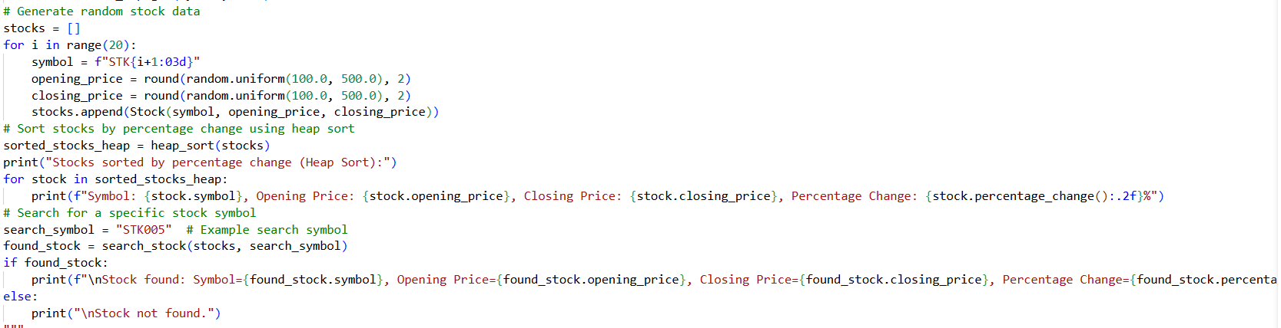
OUTPUT:
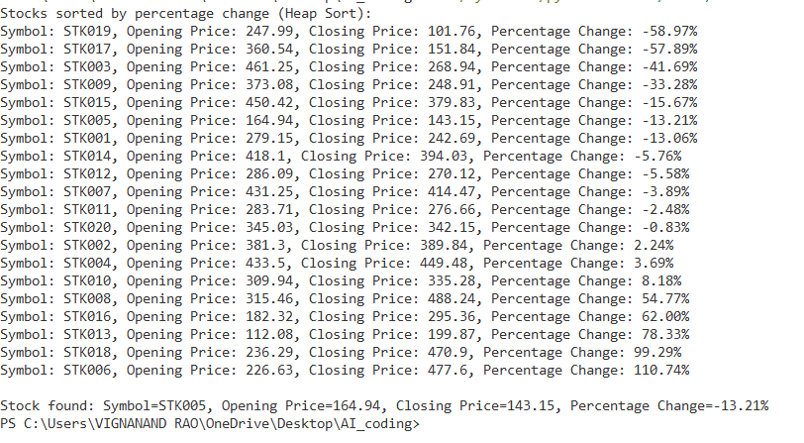
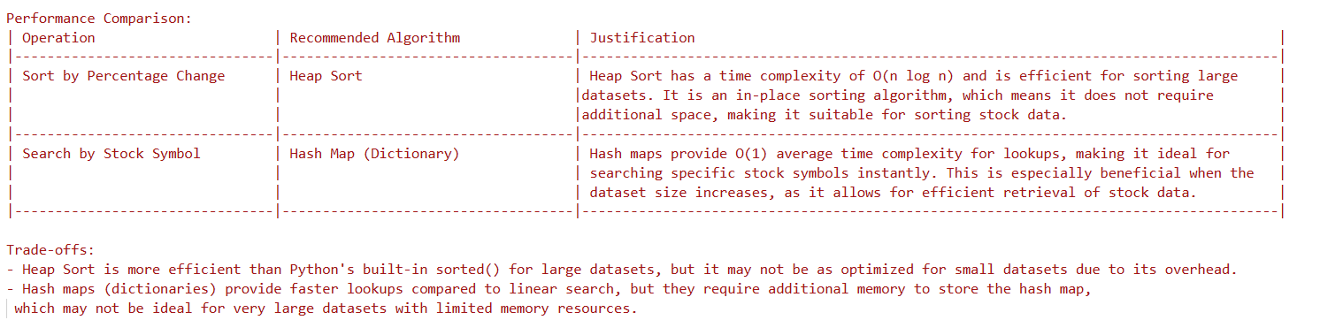
JUSTIFICATION:
In the above task, we have successfully implemented Heap Sort for sorting of stocks and Hash Maps for searching of the required stock by using stock symbols.
Heap sort has a time complexity of O(n log n) and it is efficient for sorting large datasets.
Hask Map has a time complexity of O(1).

